

**NETWORKING & SYSTEM ADMINISTRATION LAB**

**Experiment No.: 24**

**Aim**

Installation of Docker on Ubuntu

**Procedure**

step 1: Open the terminal on Ubuntu.

step 2: Remove any [Docker files](https://www.simplilearn.com/tutorials/docker-tutorial/what-is-dockerfile) that are running in the system, using the following command:

**$ sudo apt-get remove docker docker-engine docker.io**

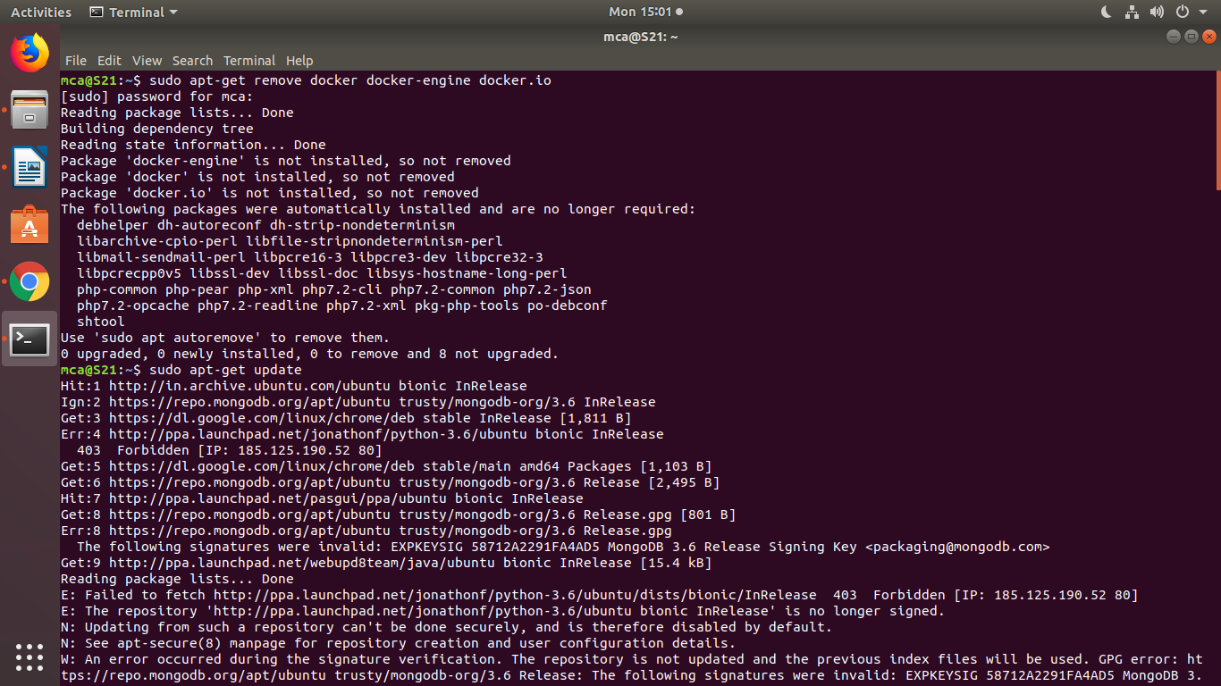

step 3: Check if the system is up-to-date using the following command:

**$ sudo apt-get update**

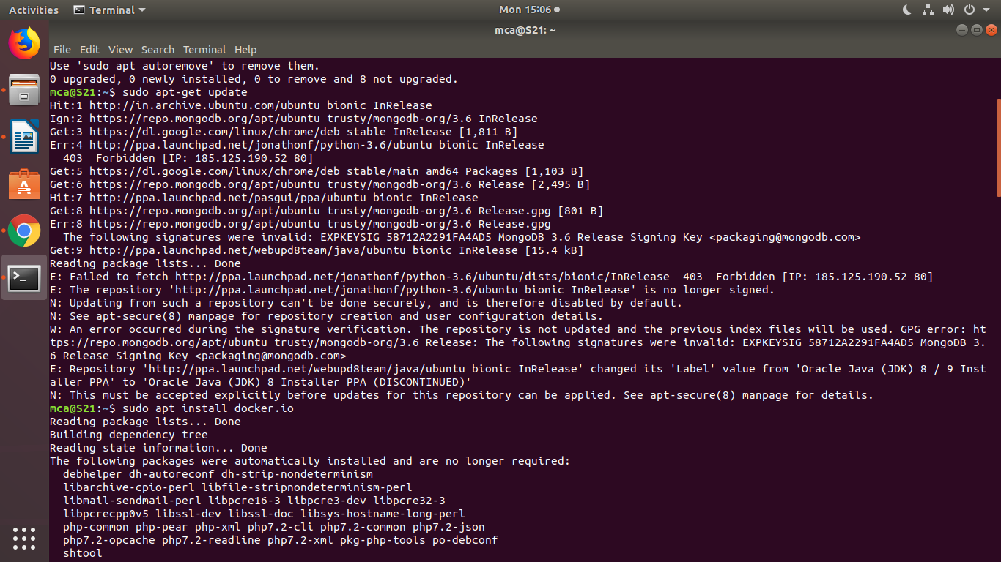

Step 4: Install Docker using the following command:

**$ sudo apt install docker.io**

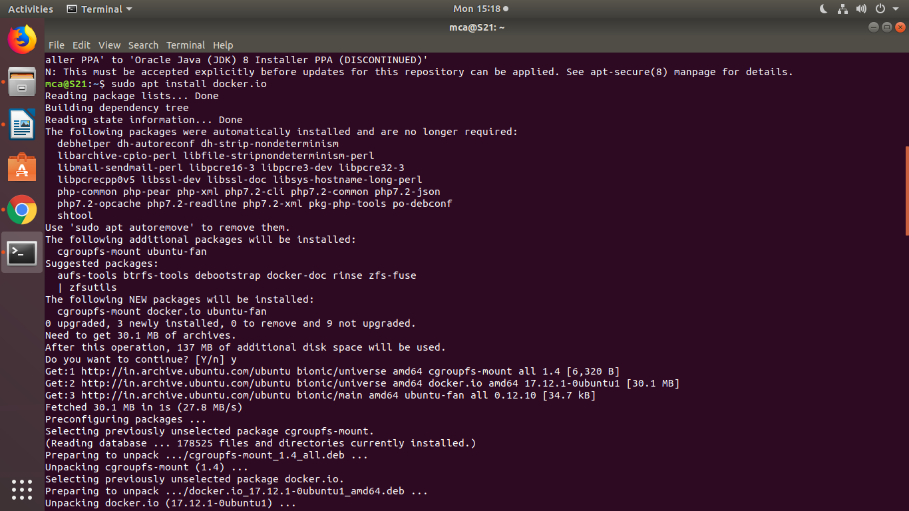

Step 5: Install all the dependency packages using the following command:

**$ sudo snap install docker**  
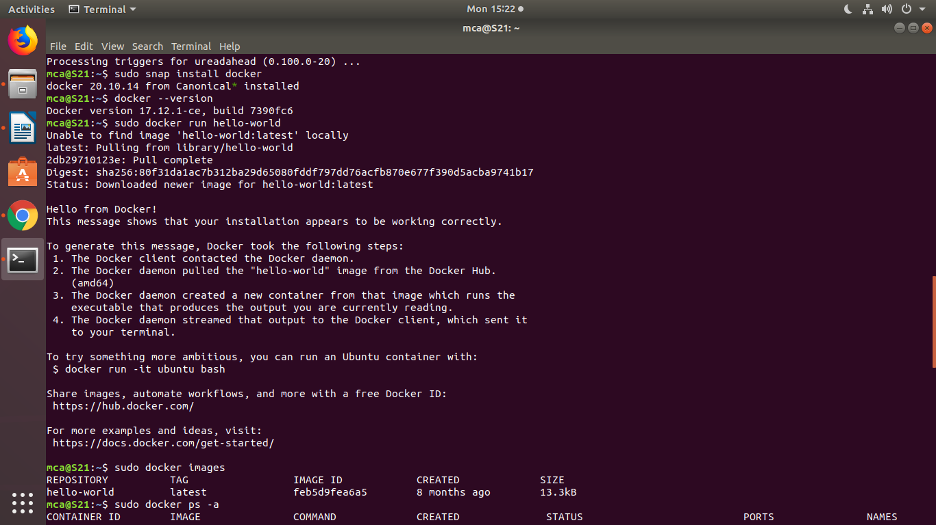

Step 6: Before testing Docker, check the version installed using the following command:

**$ docker --version**



Step 7: Pull an image from the Docker hub using the following command:

**$ sudo docker run hello-world**



Step 8: Check if the docker image has been pulled and is present in your system using the following command:

**$ sudo docker images**



Step 9: To display all the containers pulled, use the following command:

**$ sudo docker ps -a**



Step 10: To check for containers in a running state, use the following command:

**$ sudo docker ps**

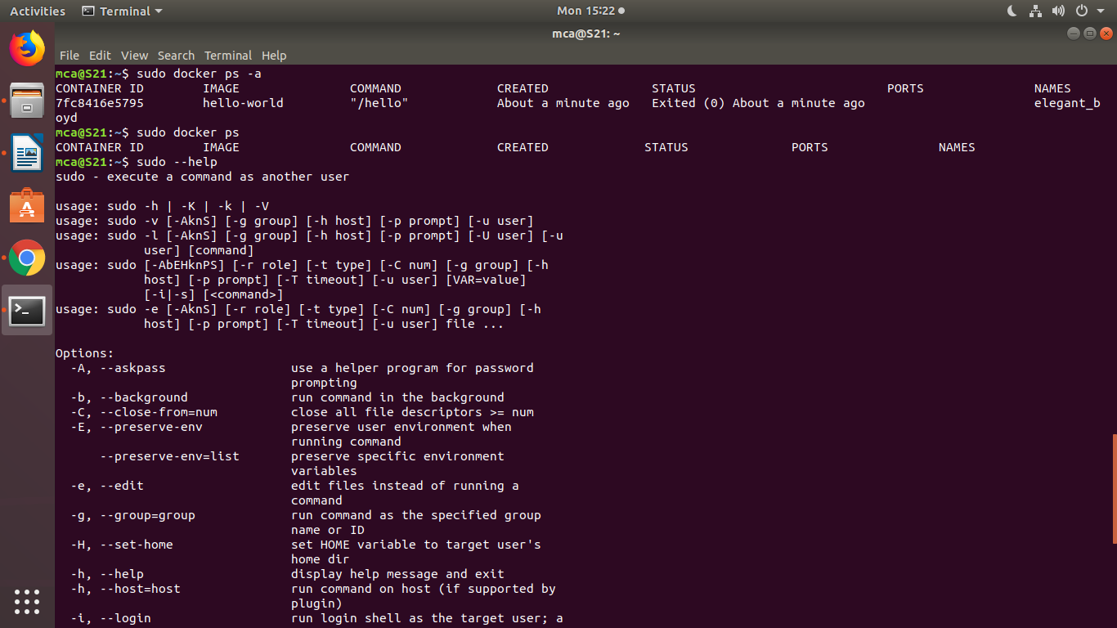

step 11: **sudo docker run -dit --name tecmint-web -p 8080:80 -v** /home/user/website/:/usr/local/apache2/htdocs/ httpd:2.4

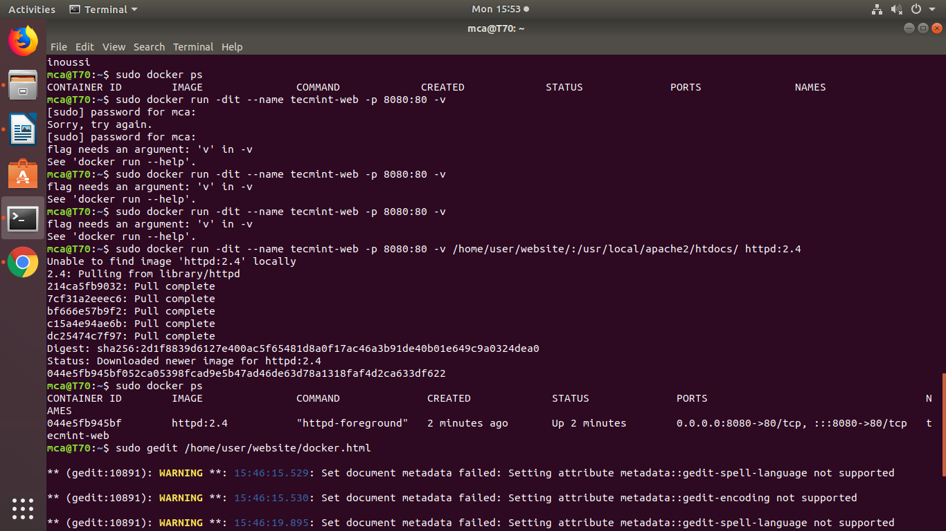

step 12: **$ sudo docker ps**



step 13 : **$ sudo gedit /home/user/website/docker.html**

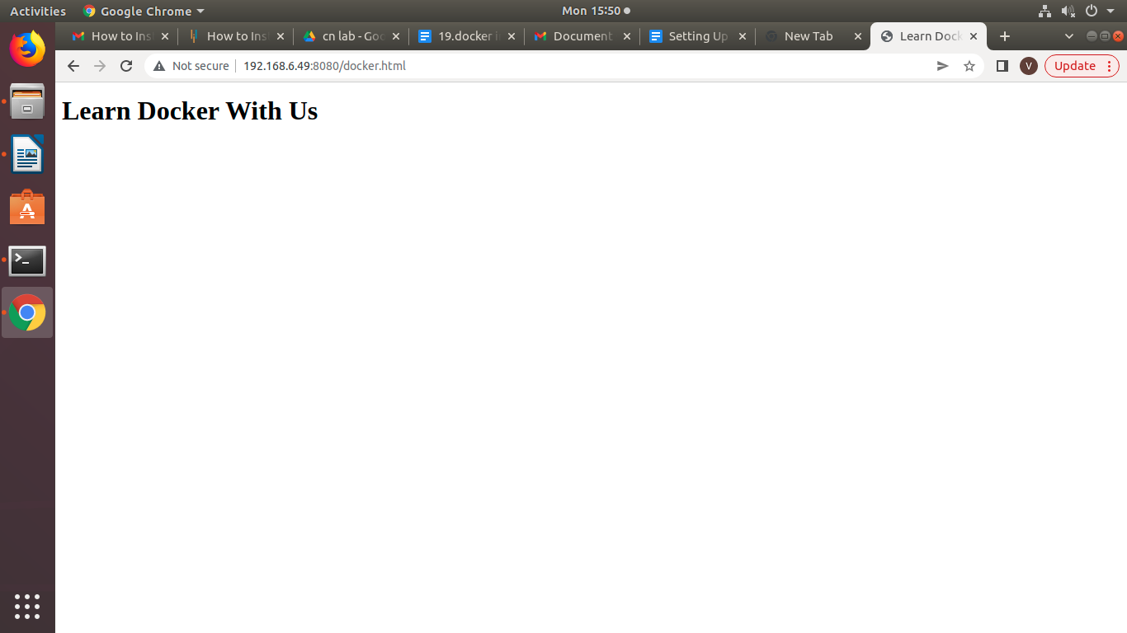

step 14 : **$ sudo docker stop tecmint-web**

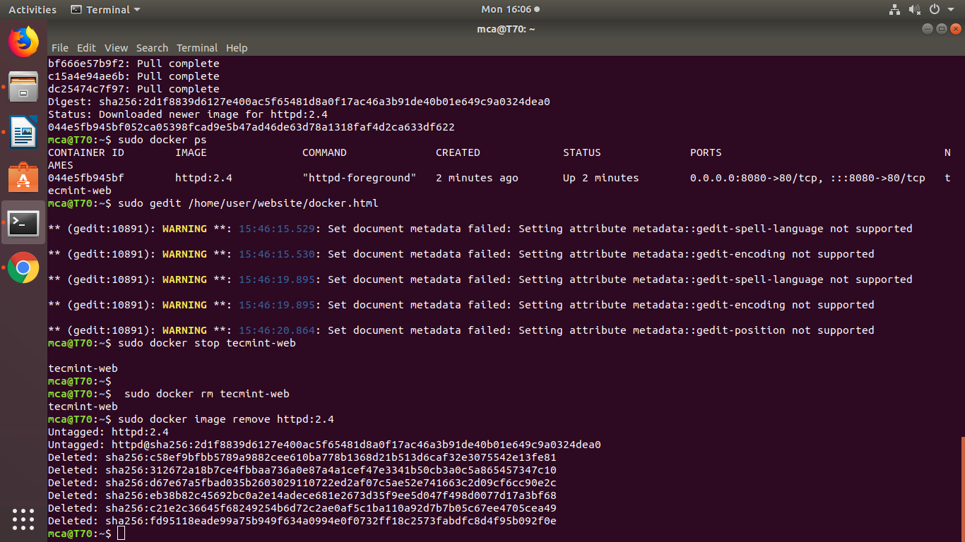

step 15:  **$ sudo docker rm tecmint-web**



step 16: **$ sudo docker image remove httpd:2.4**

